ZOOM Meeting Instructions

From March 16 – April 4, our interactions will be done online through Zoom meetings. To be able to join a meeting, you’ll first need to download Zoom on your computer or phone/tablet. Note: As of now, most chromebooks do not support Zoom software.

Below are two ways to join our meetings

Via the App
- Launch the app

- Click Join a Meeting

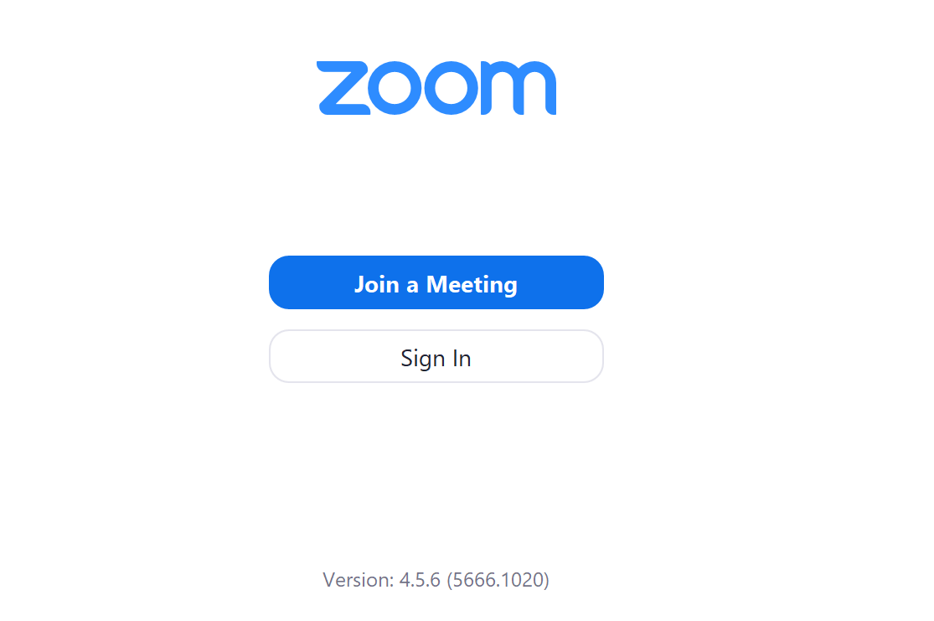

- Enter the 9 digit meeting ID that is connected to each class session. The meeting numbers for each session for the next three weeks is below. Enter your name so I can give you credit for attending these meetings.
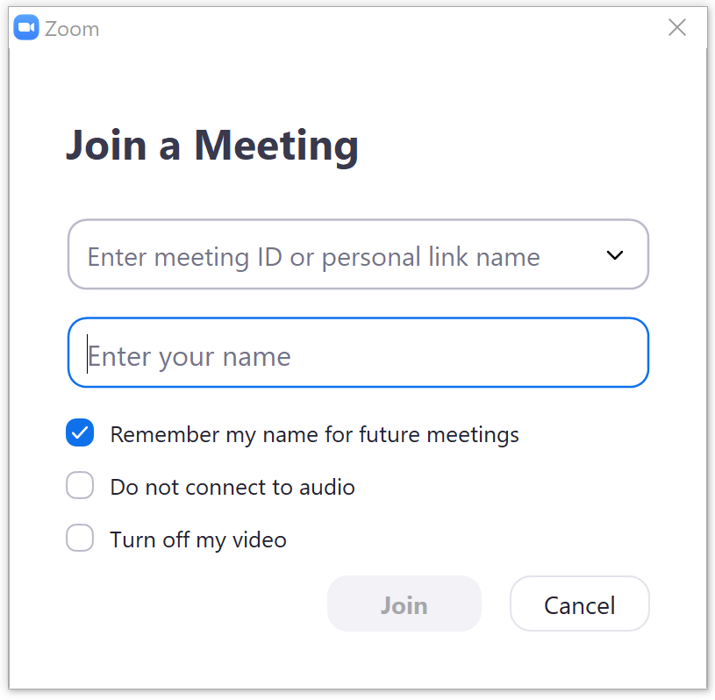
Meeting ID# for the next three weeks

03/16 7-9:05pm 904 817 620
03/18 6-6:50pm 901 174 172
03/18 7-9:05pm 672 033 219
03/23 SPRING BREAK
03/25 SPRING BREAK
03/30 7-9:05pm 213 231 274
04/01 6-6:50pm 113 983 921
04/01 7-9:05pm 664 641 806

- Click join with computer audio or to use headphones, click test speaker and microphone
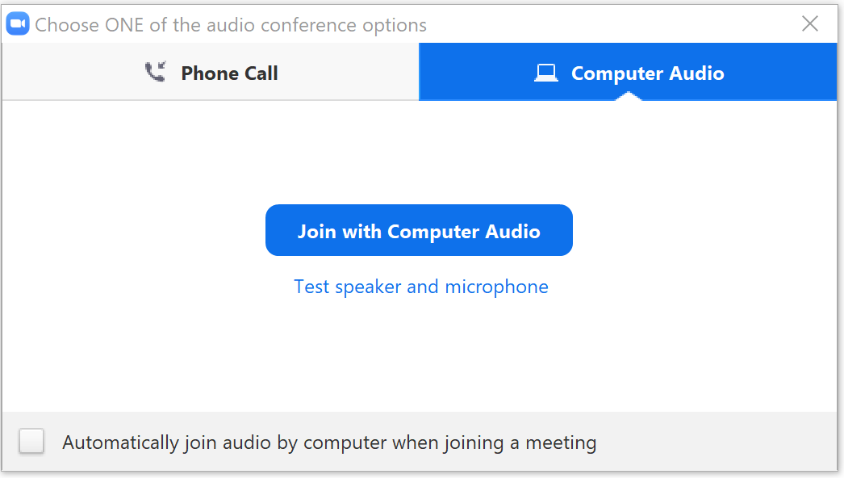

- You have joined our meetings! (Ignore my clearly brushed hair, it’s the new style)
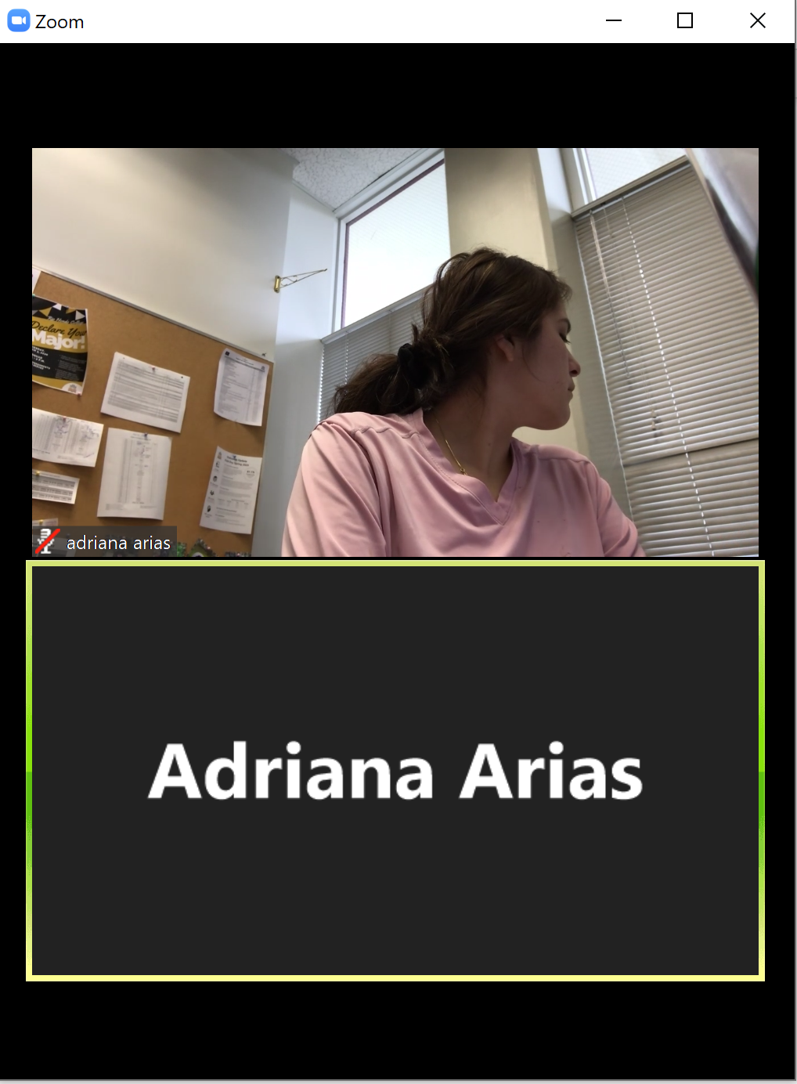

Join through Canvas.

- Log into CANVAS & click on ConferZoom
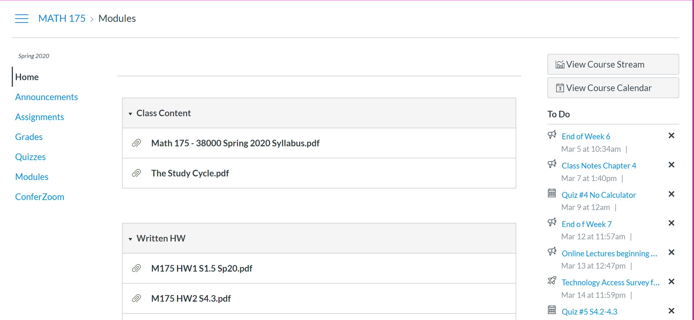

- The scheduled meetings are posted in the calendar below. Click on the + next to each event to open more details and hit JOIN.
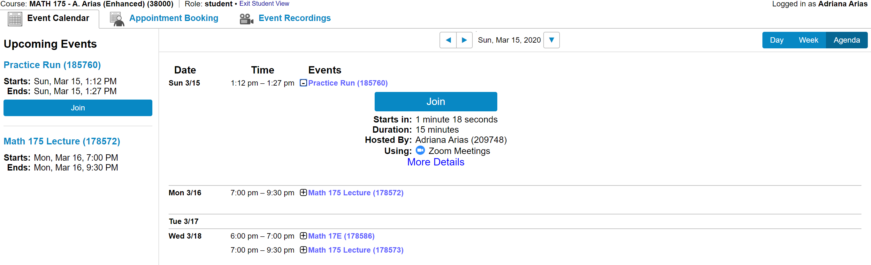

- Open Zoom meetings

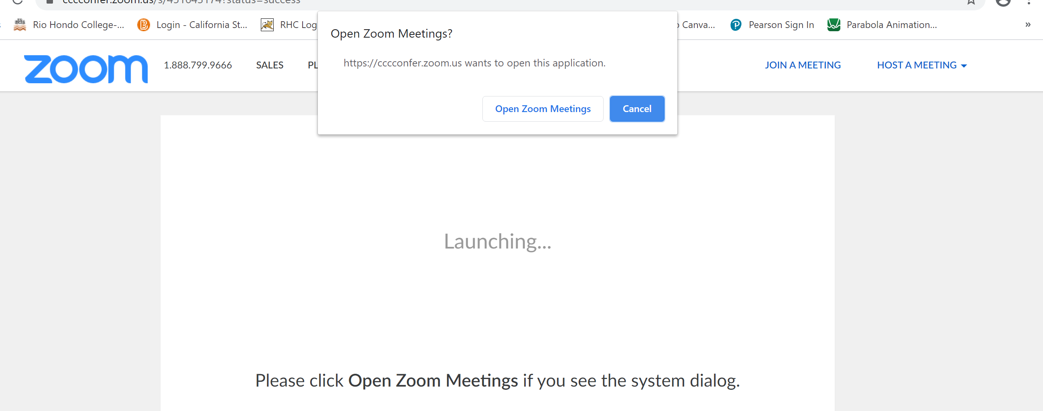

- Click join with computer audio or to use headphones, click test speaker and microphone

- You have joined our meetings! (Ignore my clearly brushed hair, it’s the new style)

