Utilizing Outcomes Rubrics without points towards grades.
When you add an outcome to a rubric--whether one that you created within a course yourself or adding one from a departmental/school subaccount that you imported into the course--Canvas gives you a checkbox called Use this criterion for scoring that will determine whether you want to use the point value. This is shown on the screen capture here, just underneath the Import Outcome heading.

If you remember to disable that checkbox, even though by all appearances the point value is still added to the rubric that you created, in fact when you save the rubric it will NOT count. This is an example: (Outcome has been blurred as it was “borrowed”.)
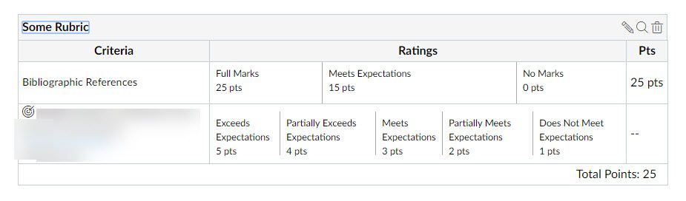
But the main thing is you MUST remember is to disable that checkbox.
The reason the point values remain in the rubric itself--though NOT in the Total Points, as you see above--is that if you imported a departmental outcome, you still have click in the rubric itself to indicate if the student met the outcome so that the departmental administrator can still pick up that information when an outcome report is run.

