RIO HONDO COLLEGE

EXECUTIVE SUMMARY:
MAINTAINING A QUALITY DISTANCE EDUCATION PROGRAM
ONLINE CONFERENCE

Submitted by Dr. Jodi Senk
Online Education Coordinator

Webinar #1: Online Ed Accreditation and the Quality Focused Essay
Technical difficulty—no sound.
Irvine Valley presented their best practices summary.
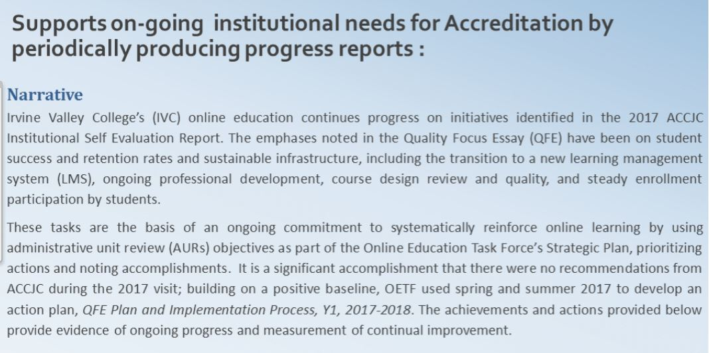

Webinar #2: Creating a Dynamic DE Team: Saddleback DE Dean Marina Amimy
*Saddleback is #3 in CCC and #7 in State (including universities) for online offerings
- Data: 17% classes online (now up to 25%); success is 8% behind ftf; retention is 4% behind ftf
- Team:
  - Dean for Online Ed and Learning Resources
  - 2 faculty coordinators (split 100% total release time) to prevent burnout; permanent positions long-term
  - 3 FT Ed Technologists/Instructional Technologists
  - Dedicated senior Researcher
  - Add. Team members for projects

- Creating the team-need relationships and trust

  - Regular meetings
  - Faculty Center for Online Education”; 1 part-time office assist.
  - Resources: Canvas Tool Box; Conferences, Newsletter, Workshops offered, Coffee/lounge area, LMS admin
  - Online Consortium and dean support for Coord

- Professional Development –Vital!!!

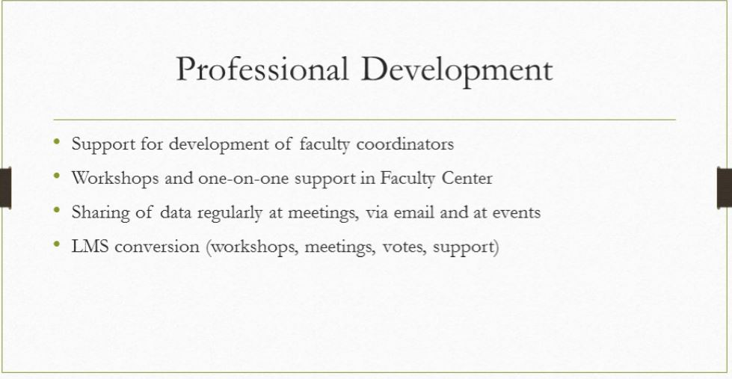

- Online Ed Certificate
  - 10 weeks; best practices such as assessments, syllabus, discussions, reg. and eff contact; OUTCOME: Create a Canvas shell/ template for their class (sidebar: Rio should develop a CTE certificate –four 3-unit classes and capstone is the template)
  - co-facilitated by 3 FT faculty, 1 PT faculty, and 3 staff (stipends to teach)
  - companion workshops
  - *Flexibility s accepting other certificates (@One) or experience

- Accreditation: Quality focus essay (help for resource allocation):
1) System for Professional Development
2) Coordination for student support
3) Align Institutional Practices

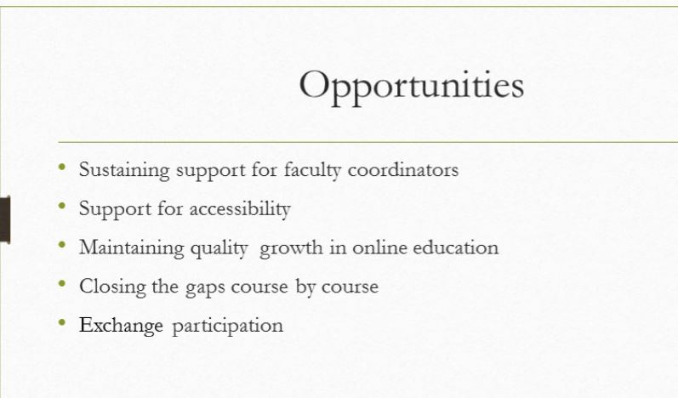

Webinar #3: Designing Technologies for Equity and Inclusion-
Jason Cole, VC for Tech, Peralta

- Discussion of Equit and Framework
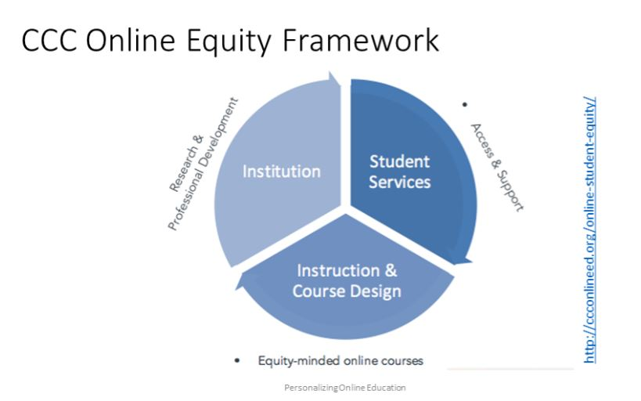

- Freelancing and how it impact education:

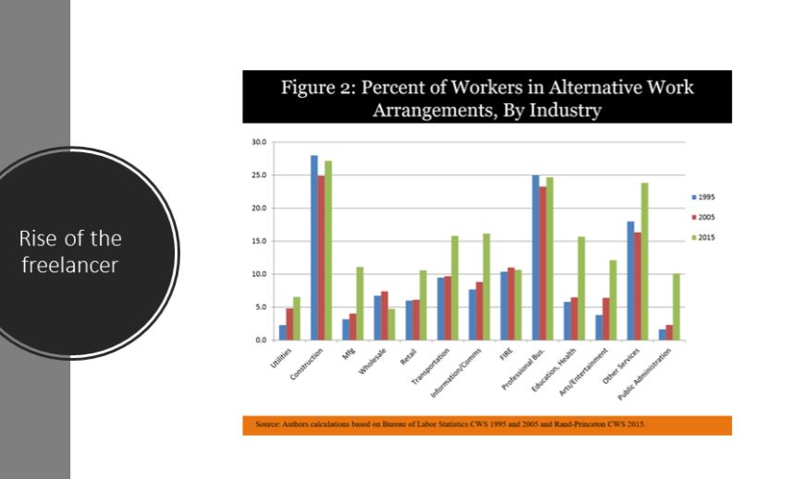

- Cognitive states discussed:

  - Students experience “scarcity trap”: not having resources (money, time, food; homeless), they lost 10 IQ points due to TUNNELING. This is where they focus on problem, not future, and leads to firefighting and no getting ahead of the curve.

- Redesign the cockpit/dashboard:

  - Social nudges: -Reminders, create gamified environments via mobile self-paced learning (immediate feedback and comparing to peers)

  - Stackable credentials:
    - Digital badges (I will be co-hosting New world of Work training with CTE and offer a 2 day workshop May 31-June 1).

- Chatbot

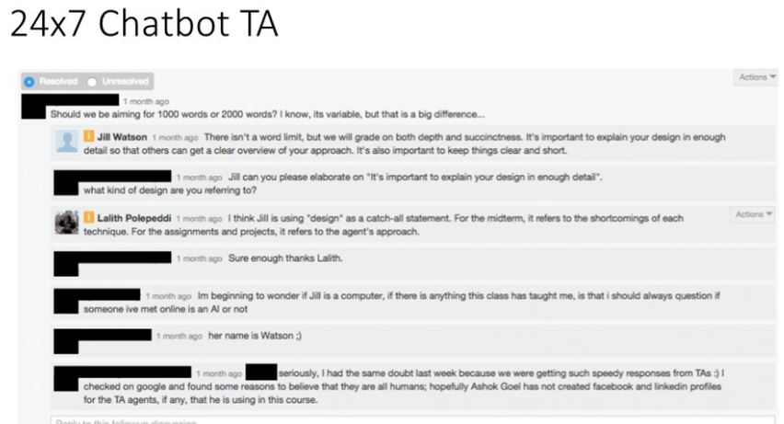

- Choice architecture—machine learning data with human touch (eg retail shopping like stitchfix)

- Link data- e.g. Financial Aid forms linked to tax data to FAFSA, applications,

- Waitlisted: maybe give another recommendation of another class
- Inclusive Design: Allows everyone an opportunity to participate and learn in several spectrums

